PSI Photo Guidelines
This image will be used in you certificate of registration.
If the uploaded image does not meet the standards outlined below (Passport Photo style), it will delay processing your application as you will be requested to upload a photo that meets the required standards.
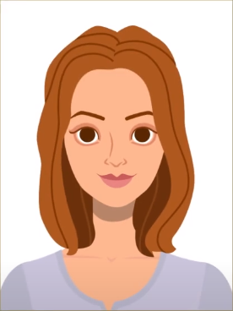

Facial features and expression:
- Ensure your facial features are visible, hair should not cover any part of the eyes.
- You can wear glasses. The frame must not cover any part of your eyes. There must be no glare on the lenses. Dark glasses are not permitted.
- Do not wear sunglasses.
- You can wear a head covering for religious or medical reasons. Your full facial features must be visible. You cannot wear head accessories for any other reason.
- Do not tilt your head up/down or left/right. Look straight into the camera.

Background and distance:
- The photo must capture head and shoulders (Passport Photo style).
- You need to stand in front of a completely plain, light grey, white or cream background.
- No objects such as door panels or plants should be visible.
- Uniforms, whether civil or military, or clothing bearing insignia are not permitted.
- Please ensure there is visible space between your head and shoulders and the edge of your photo.

Lightning and focus
- Your photo must be in focus. Balance the lighting and colour, not too dark or too light.
- The photo must be in colour.

General guidelines:
- Photo should be in portrait orientation.
- Photographs should not be more than 6 months old.
- Not be a scanned photo.
- Not be less than 715 pixels wide and 951 pixels in height. All smart phone cameras will capture the required pixels.
- Not have compression, loss or compression artefacts.
- Not be digitally enhanced or changed.
- Not contain barrel or other distortion.
- Maximum size: 5 MB. Accepted formats: JPG, JPEG or PNG.

